The 11th International Conference Analytical Models
and New Concepts in Concrete and Masonry Structures

http://www.amcm2024.p.lodz.pl/

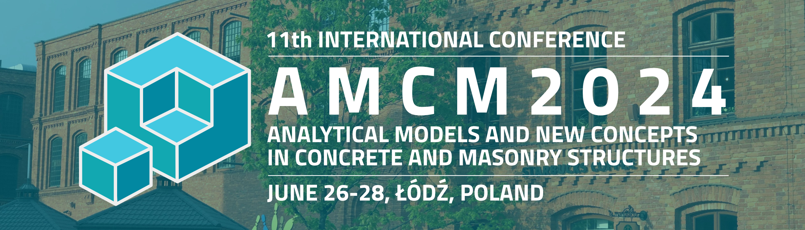

www.pzitb.lodz.pl/AMCM (temporary)

ORGANIZING COMMITTEE

Chairman of the OC - Renata Kotynia; Vice Dean for Collaboration, Faculty of Civil Engineering, Architecture and Environmental Engineering, Lodz University of Technology

Organizing Committee
Chairman of the OC – Renata Kotynia; Vice-Dean for Development; Faculty of Civil Engineering, Architecture and Environmental Engineering, Lodz University of Technology
Vice Chairman of the OC - Dariusz Gawin; Dean, Faculty of Civil Engineering, Architecture and Environmental Engineering, Lodz University of Technology

Tomasz Waśniewski – webpage organizer

Department of Concrete Structures:
Tadeusz Urban, Marek Lefik, Michał Gołdyn, Ewelina Kołodziejczyk, Łukasz Krawczyk, Marcin Starzec, Martyna Rabenda, Marek Wojciechowski, Damian Szczech, Konrad Szczepański, Janusz Rogowski, Anna Hummel, Radosław Walendziak

Department of Building Materials Physics and Sustainable Design:
Jakub Miszczak, Elżbieta Habiera -Waśniewska, Iwona Szer, Monika Kaszubska

Secretary:
Magdalena Sofijska, Anna Łączyńska, Marcin Janecki

Finanse:
Agnieszka Kobalczyk – Financial Questor LUT
HONORARY PATRONS

Marshal of the Lodz Voivodship | Grzegorz Schreiber
Vice- Marshal of the Lodz Voivodship | Piotr Adamczyk
Mayor of the City of Lodz | Hanna Zdanowska
Governor of Lodz | Tobiasz Bocheński
Chairmen of the Committee on Civil Engineering of the Polish Academy of Sciences | Prof. Kazimierz Furtak
General Director of National Roads and Highways | Tomasz Żuchowski
Rector of Lodz University of Technology | Krzysztof Jóźwik | 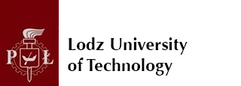
Section of Concrete Structures Polish Academy of Science; Committee on Civil Engineering of the Polish Academy of Sciences | Prof. Anna Halicka | 
Polish Group of Fédération Internationale du Béton (fib) – Wit Derkowski | Prof. Wit Derkowski | 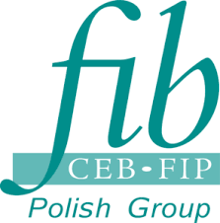
Fédération Internationale du Béton (fib) - President | Steven Foster | 
Polish Group of Association for Bridge and Structural Engineering | Prof. Jan Bień | 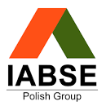
Chairman of Polish Chamber of Civil Engineers | Mariusz Dobrzeniecki | 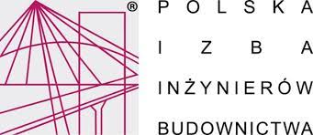
Chairman of Lodz District Chamber of Civil Engineers | Prof. Jacek Szer | 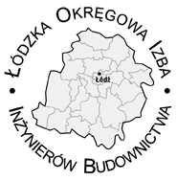
Chairman of the Scientific Committee of the Polish Association of Construction Engineers and Technicians | Prof. Cezary Madryas | 
Chairman of the Scientific Committee of the Lodz Association of Construction Engineers and Technicians | Prof. Renata Kotynia | 
Chairman of the Lodz Association of Construction Engineers and Technicians | Dr Przemysław Bodzak

International patrons:
- American Concrete Institute (ACI) https://www.concrete.org/home.aspx
- Fib International Institute for FRP in Construction (IIFC) https://www.iifc.org/
- International Union of Laboratories and Experts in Construction Materials, Systems and Structures (RILEM, from the name in French) https://www.rilem.net/
- International Association for Bridge and Structural Engineering (IABSE) https://www.iabse.org/
- International Institute for FRP in Construction (IIFC) https://www.iifc.org/

International Advisory Committee

Erkan Akpinar (Turkey)  Riadh Al- Mahaidi (Australia)  György Balázs (Hungary)  Sisir Kumar Banerjee (India)  Nemkumar Banthia (Canada)  Joaqium Barros (Portugal)  Oguzhan Bayrak (USA)  Brahim Benmokrane (Canada)  Hans-Dieter Beushausen (South Africa)  Agnieszka Bigaj -van Vliet (Netherlands)  Billy Boshoff (South Africa)  Laurent Boutillon (France)  Mikael Braestrup (Denmark)  Robby Caspeele (Belgium)  Vladimir Cervenka (Czech Republic)  Marta Choińska (France)  David Citek (Czech Repu blic)  Hugo Corres Peiretti (Spain)  Manfred Curbach (Germany)  Avraham Dancygier (Israel)  Albert De la Fuente (Spain)  Steve Denton (United Kingdom)  Frank Dehn (Germany)  Wit Derkowski (Fib Polish Group)  Jean-François Destrebecq (Franc e)  Gerrie Dieteren (Netherland s)  Ir ia Licia Oliva Doniak (Brazil)  Marco Di Prisco (Italy )  Rolf Eligehausen (Germany)  Michael Fardis (Greece)  Jian-Fei Chen (United Kingdom)  Peng Feng (China)  David Fernández-Ordóñez (Spain)  Oliver Fischer (Germany)  Stephen Foster (Austra lia)  Hans Rudolf Ganz (Switzerland)  Petr Hajek (Czech Republic)  Josef Hegger (Germany)  Steinar Helland (Norway)  Sung-Gul Hong (South- Korea)  Dick Hordijk (Netherlands)  Alper İlki (Turkey)  Akio Kasuga (Japan)  Johann Kollegger (Austria)  Xillin Lu (China)  Valter J. G. Lucio (Portugal) | Karin Lundgren (Sweden)  Koichi Maekawa (Japan)  Giuseppe Mancini (Italy)  Tor Arne Martius -Hammer (Norway)  Stuart Matthews (United Kingdom)  Alberto Meda (Italy)  Urs Meier (Switzerland)  Marco Menegotto (Italy)  Boyan Mihaylov (Belgium)  Giorgio Monti (Italy)  Michel Moussard (France)  Masoud Motavalli (Switzerland)  Harald Müller (Germany)  Aurelio Muttoni (Switzerland)  Hikaru Nakamura (Japan)  Antonio Nanni (USA)  Piotr Noakowski (Germany)  Andrzej Nowak (USA)  Ilham Nurhuda (Indonesia)  Pedro de Oliveira Almeida (Brazil)  Alessandro Palermo (New Zealand)  Frank Papworth (Australia)  Brett Pielstick (USA)  Giovanni Plizz ari (Italy)  Marianna Polak (Canada)  Koji Sakai (Japan)  Theo Salet (Netherla nds)  Erik Schlangen (Netherlands )  Takumi Shimomura (Japan)  Johan Silfwerbrand (Switzerland)  Jongsung Sim (South-Korea)  Andreas Sjaastad (Norway)  Alfred Strauss (Austria)  Piti Sukontasukkul (Thailan d)  Luc Taerwe (Belgium)  José Torero (Australia)  Jean Michel Torrenti (France)  Thanasis Triantafillou (Greece)  Tamon Ueda (Japan)  Jan L. Vitek (Czech Republic)  Joost Walraven (Netherlands)  Zhishen Wu (Japan)  Sherif Yehia (United Arab Emirates)  Yong Yuan (China)  Stef Maas (Belgium)  Peter Mark (Germany)

Polish Scientific Committee

Prof. dr hab. inż. Jan Bień Politechnika Wrocławska
Prof. dr hab. inż. Ewa Błazik-Borowa Politechnika Lubelska
Prof. dr hab. inż. Jan Biliszczuk Politechnika Wrocławska
Dr hab. inż., Prof. PŁ Robert Cichowicz Politechnika Łódzka
Prof. dr hab. inż. Lech Czarnecki Instytut Techniki Budowlanej
Prof. dr hab. inż. Jan Deja Akademia Górniczo-Hutnicza
Dr hab. inż., Prof. PK Wit Derkowski Politechnika Krakowska
Prof. dr hab. inż. Łukasz Drobiec Politechnika Śląska
Prof. dr hab. inż. Kazimierz Flaga Politechnika Krakowska
Prof. dr hab. inż. Kazimierz Furtak Politechnika Krakowska
Prof. dr hab. inż. Dariusz Gawin Politechnika Łódzka
Prof. dr hab. inż. Andrzej Garbacz Politechnika Warszawska
Prof. dr hab. inż. Marian Giżejowski Politechnika Warszawska
Prof. dr hab. inż. Barbara Goszczyńska Politechnika Świętokrzyska
Prof. dr hab. inż. Krzysztof Gromysz Politechnika Śląska
Prof. dr hab. inż. Anna Halicka Politechnika Lubelska
Prof. dr hab. inż. Jerzy Hoła Politechnika Wrocławska
Prof. dr hab. inż. Jacek Hulimka Politechnika Śląska
Prof. dr hab. inż. Marcin Kamiński Politechnika Łódzka
Prof. dr hab. inż. Barbara Klemczak Politechnika Śląska
Prof. dr hab. inż. Robert Kowalski Politechnika Warszawska
Prof. dr hab. inż. Jan Kubica Politechnika Śląska
Prof. dr hab. inż. Maria Kaszyńska Zachodniopomorski Uniwersytet Technologiczny w Szczecinie
Prof. dr hab. inż. Zbigniew Kledyński Politechnika Warszawska
Prof. dr hab. inż. Cezary Madryas Politechnika Wrocławska
Prof. dr hab. inż. Krystyna Nagrodzka-Godycka Politechnika Gdańska
Prof. dr hab. inż. Adam Podhorecki Uniwersytet Technologiczno-Przyrodniczy w Bydgoszczy
Prof. dr hab. inż. Wojciech Radomski Politechnika Warszawska
Prof. dr hab. inż. Anna Siemińska-Lewandowska Politechnika Warszawska
Prof. dr hab. inż. Antoni Szydło Politechnika Wrocławska
Prof. dr hab. inż. Tomasz Siwowski Politechnika Rzeszowska
Prof. dr hab. inż. Marek Salamak Politechnika Śląska
Prof. dr hab. inż. Andrzej Seruga Politechnika Krakowska
Prof. dr hab. inż. Adam Stolarski Wojskowa Akademia Techniczna
Dr hab. inż., Prof. PŁ Jacek Szer Politechnika Łódzka
Prof. dr hab. inż. Elżbieta Szmigiera Politechnika Warszawska
Prof. dr hab. inż. Leszek Szojda Politechnika Śląska
Prof. dr hab. inż. Grzegorz Świt Politechnika Świętokrzyska
Prof. dr hab. inż. Jacek Śliwiński Politechnika Krakowska
Prof. dr hab. inż. Andrzej Ubysz Politechnika Wrocławska
Prof. dr hab. inż. Tadeusz Urban Politechnika Łódzka
Prof. dr hab. inż. Andrzej Winnicki Politechnika Krakowska
Prof. dr hab. inż. Krzysztof Wilde Politechnika Gdańska
Prof. dr hab. inż. Adam Zybura Politechnika Śląska
Prof. dr hab. inż. Henryk Zobel Politechnika Warszawska

Medial Patronage
- PWN https://www.pwn.pl/
- Inżynieria i Budownictwo https://www.inzynieriaibudownictwo.pl/
- Materiały Budowlane https://www.materialybudowlane.info.pl/
- Przegląd Budowlany https://www.przegladbudowlany.pl /
- Inżynier Budownictwa https://inzynierbudownictwa.pl /
- Nowoczesne Budownictwo Inżynieryjne http://www.nbi.com.pl/czasopismo /
- Autostrady https://lp.elamed.pl/mau /
- Mosty https://lp.elamed.pl/mos/
- Architektura & Biznes https://www.architekturaibiznes.pl/
Topics
Concrete and Innovative Materials
- Concrete materials
- Concrete in complex stress state
- Behaviour and application of HPC in structures
- Reinforced and prestressed concrete structures
- Composite materials - theory, practice and new standards
- Durable and sustainable concrete design
- Circularity in construction
- Testing and assessment methods
- Cyclic and long-term loading of concrete structures
- Digital construction with concrete
- Low carbon building materials for green construction
- Materials for renovated energy-efficient buildings
Structural Performance and Design
- Advances in structural design
- Numerical modelling
- Models for concrete structures analysis according to new Codes
- Deep learning for structural engineering
- Seismic vulnerability and risk assessment
- Advanced strengthening and retrofitting solutions for existing concrete structures
- New trends in structural health monitoring
- Non-Deterministic models for structural health monitoring
- Structural behavior and experimental investigations
- Life-Cycle performance assessment of civil engineering systems
Construction Methods and Management
- Precast and prestressed concrete
- Composite structures
- Building Information Modelling
- Management systems
- New trends in construction techniques
- Digital technologies shaping the construction
- Assessment of existing structures
Outstanding Structures
- Achievements in modelling and design of bridges
- Buildings and bridges
- Tunnels solutions
- Nuclear power plants
- Hydraulic and offshore structures
- Transportation projects
- Foundation systems
- Other special structures
Masonry strutures
- Design rules in masonry structures - codes
- Assessment of existing masonry structures
- Modelling of masonry structures
- Historical masonry structures
- Types of mortars of masonry structures
- Structural degradation of masonry
- Existing historical masonry structures
- Probabilistic modeling of aging masonry

Special publications

- Special Issue of Structural Concrete masonry– waiting for a decision of Fib
- Special Publication American Concrete Institute – waiting for a decision of ACI
- Special Publication RILEM – waiting for a decision of RILEM

- Archives of Civil Engineering
- Engineering Structures
- Cement & Concrete Structures
- Computer Methods in Applied Mechanics and Engineering

Conference Address:
Faculty of Civil Engineering, Architecture and Environmental Engineering,
Lodz University of Technology
Al. Politechniki 6, 93-590 Lodz, Poland

Conference Venue
Lodz University of Technology Conference Center - Alchemium
Żeromskiego 114, 90-924 Lodz, Poland

Phones:
+48 42 631-35-75
+48 42 631-35-92
+48 42 631-38-70
E-mail: amcm2024@info.p.lodz.pl

